ID: VU4F2223028 Exp. No: 01 Security Lab

**Aim:** Implementation of Caesar Cipher.

**Program:**

import java.util.Scanner;

public class CaesarCipher {

public static void main(String[] args) {

Scanner scanner = new Scanner(System.in);

System.out.println("Choose operation:");

System.out.println("1. Encryption");

System.out.println("2. Decryption");

System.out.println("0. Exit");

int choice;

do {

System.out.print("Enter your choice: ");

choice = scanner.nextInt();

scanner.nextLine(); // Consume newline character left by nextInt()

switch (choice) {

case 1:

System.out.print("Enter plaintext: ");

String plainText = scanner.nextLine().toUpperCase();

String encryptedText = encrypt(plainText);

System.out.println("Encrypted text: " + encryptedText);

break;

case 2:

System.out.print("Enter encrypted text: ");

String encryptedInput = scanner.nextLine().toUpperCase();

String decryptedText = decrypt(encryptedInput);

System.out.println("Decrypted text: " + decryptedText);

break;

case 0:

System.out.println("Exiting...");

break;

default:

System.out.println("Invalid choice. Please enter 1, 2, or 0.");

break;

}

} while (choice != 0);

scanner.close();

}

// Method to encrypt plaintext using Caesar Cipher

public static String encrypt(String plainText) {

StringBuilder encryptedText = new StringBuilder();

int shiftKey = 3; // Fixed shift key

for (int i = 0; i < plainText.length(); i++) {

char ch = plainText.charAt(i);

if (Character.isLetter(ch)) {

char shifted = (char) ('A' + (ch - 'A' + shiftKey) % 26);

encryptedText.append(shifted);

} else {

encryptedText.append(ch); // Append non-letter characters unchanged

}

}

return encryptedText.toString();

}

// Method to decrypt encrypted text using Caesar Cipher

public static String decrypt(String encryptedText) {

StringBuilder decryptedText = new StringBuilder();

int shiftKey = 3; // Fixed shift key

for (int i = 0; i < encryptedText.length(); i++) {

char ch = encryptedText.charAt(i);

if (Character.isLetter(ch)) {

char shifted = (char) ('A' + (ch - 'A' - shiftKey + 26) % 26);

decryptedText.append(shifted);

} else {

decryptedText.append(ch); // Append non-letter characters unchanged

}

}

return decryptedText.toString();

}

}

**Output:**

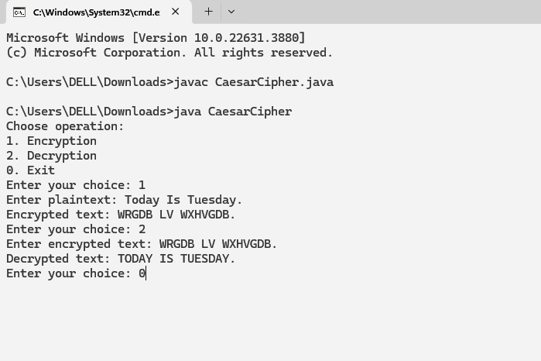

**Conclusion:**

We have suscessfully implemented Caesar Cipher.

TE-IT-A VPPCOE & VA Page No: 01